**Sanika Kadam 2124UCSF1112**

**1.Introduction**

Write a program that uses a table layout to create a restaurant data entry form. Include fields like "Restaurant Name," "Location," and "Cuisine Type." Add a set of radio buttons to let the user select the type of restaurant (e.g., "Fast Food," "Fine Dining," or "Cafe"). Use this to design a user-friendly interface for restaurant owners to input their data.

**2. Tools & Technologies Used**

* Android Studio
* Java/Kotlin (Kotlin)
* Emulator or Physical Device ()

**3. Procedure & Steps**

**Step 1: Create a New Project**

* Open Android Studio and create a new project.
* Choose an Empty Activity template.
* Set the project name and package name.
* Select the programming language (Java/Kotlin).

**Screenshot:**

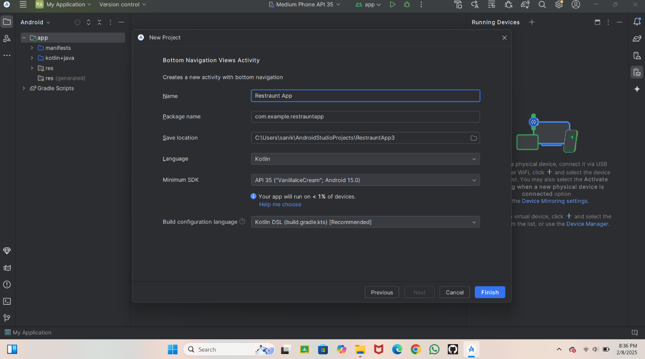**Step 2: Designing the UI**

* Open activity_main.xml and design the layout using XML.
* Add UI comwponents such as TextView, EditText, Button, etc.

**Screenshot**

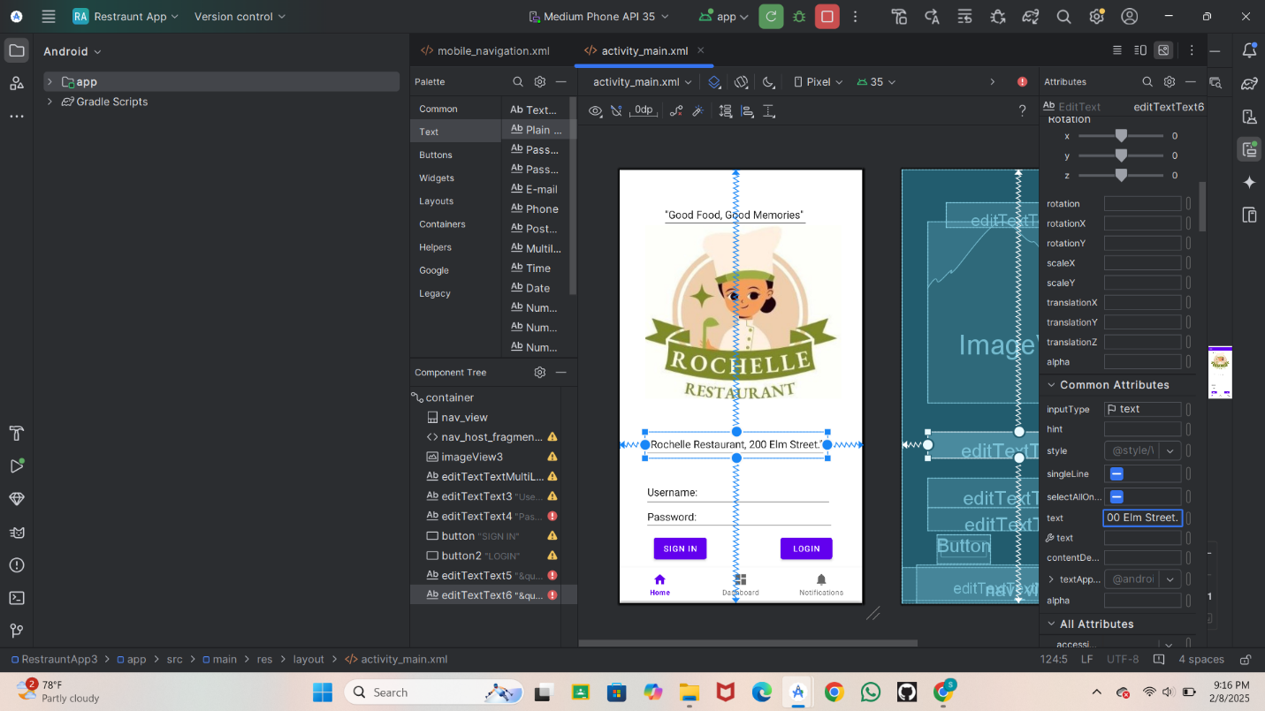

**Step 3: Writing the Code**

* Open MainActivity.java or MainActivity.kt.
* Implement functionality such as button clicks, form validation, etc.
* Use necessary Android components like Intents, RecyclerView, Fragments, etc.

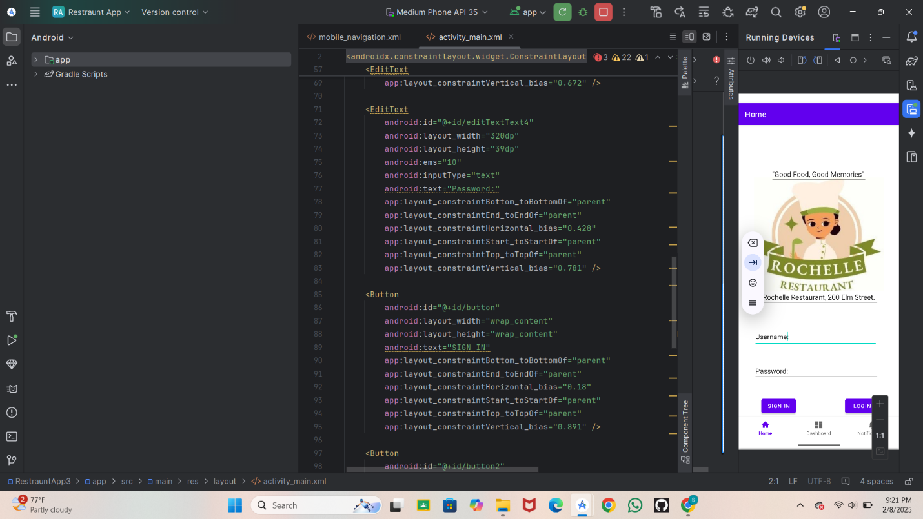

For connecting to other page on button

* Go on New
* Activity
* Empty View Activity

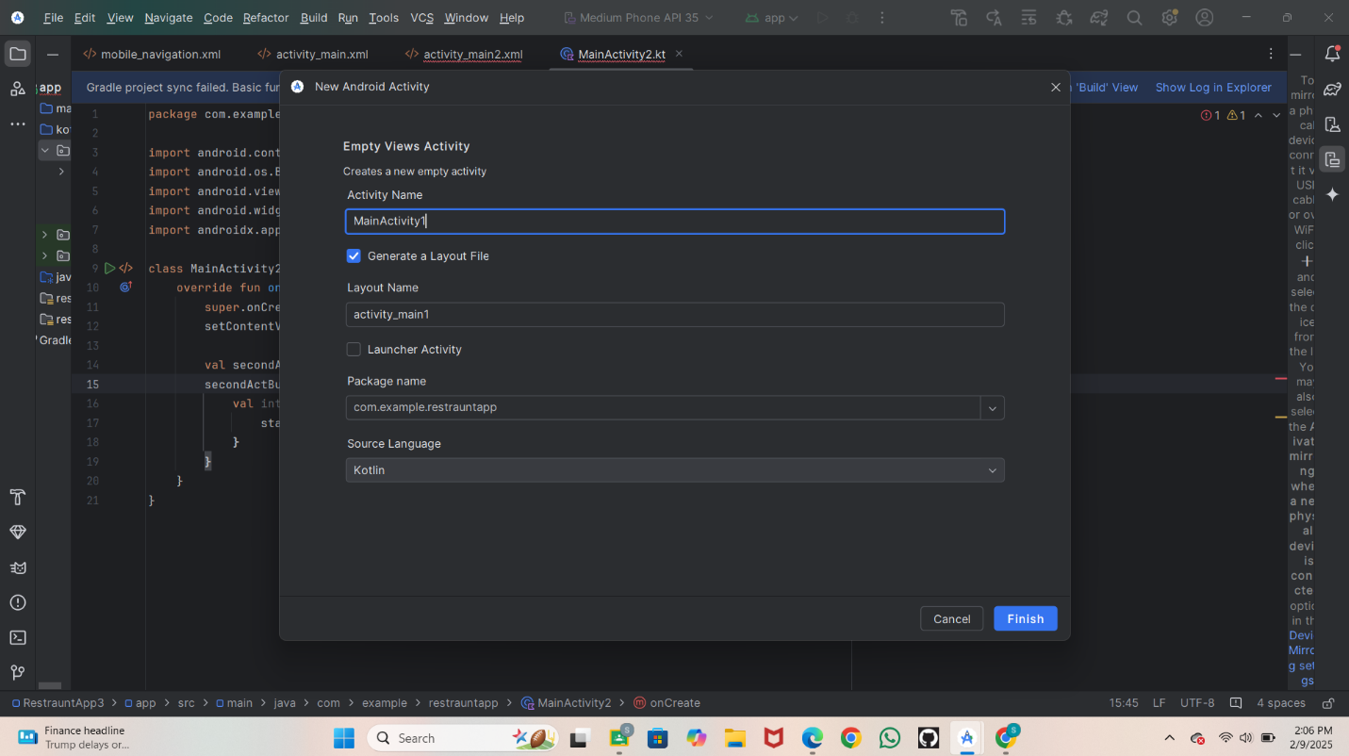java

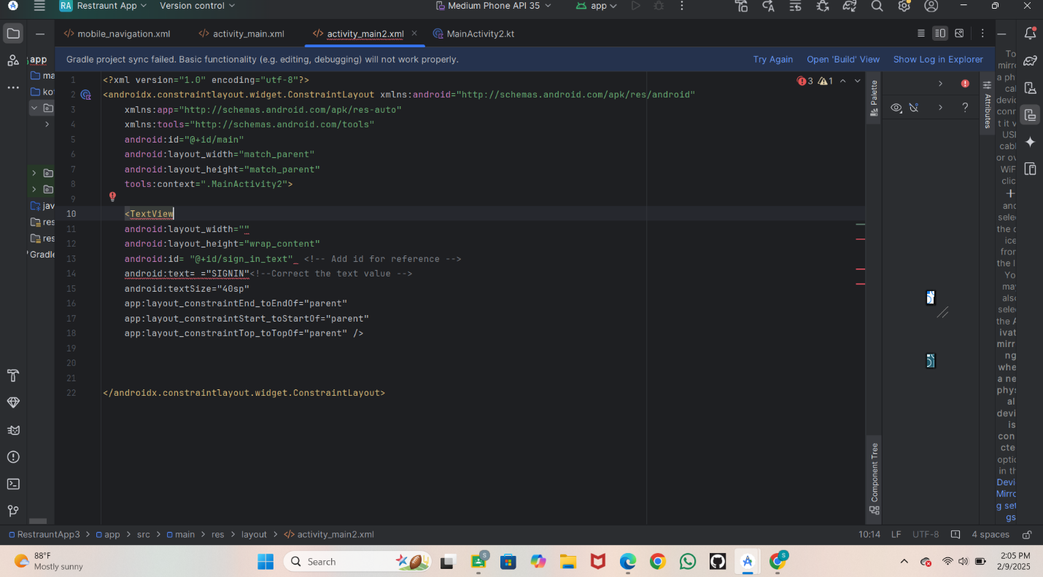CopyEdit

// Example Java Code

public class MainActivity extends AppCompatActivity {

    @Override

    protected void onCreate(Bundle savedInstanceState) {

        super.onCreate(savedInstanceState);

        setContentView(R.layout.activity_main);

        Button btn = findViewById(R.id.myButton);

        btn.setOnClickListener(view ->

            Toast.makeText(this, "Button Clicked!", Toast.LENGTH_SHORT).show()

        );

    }

}

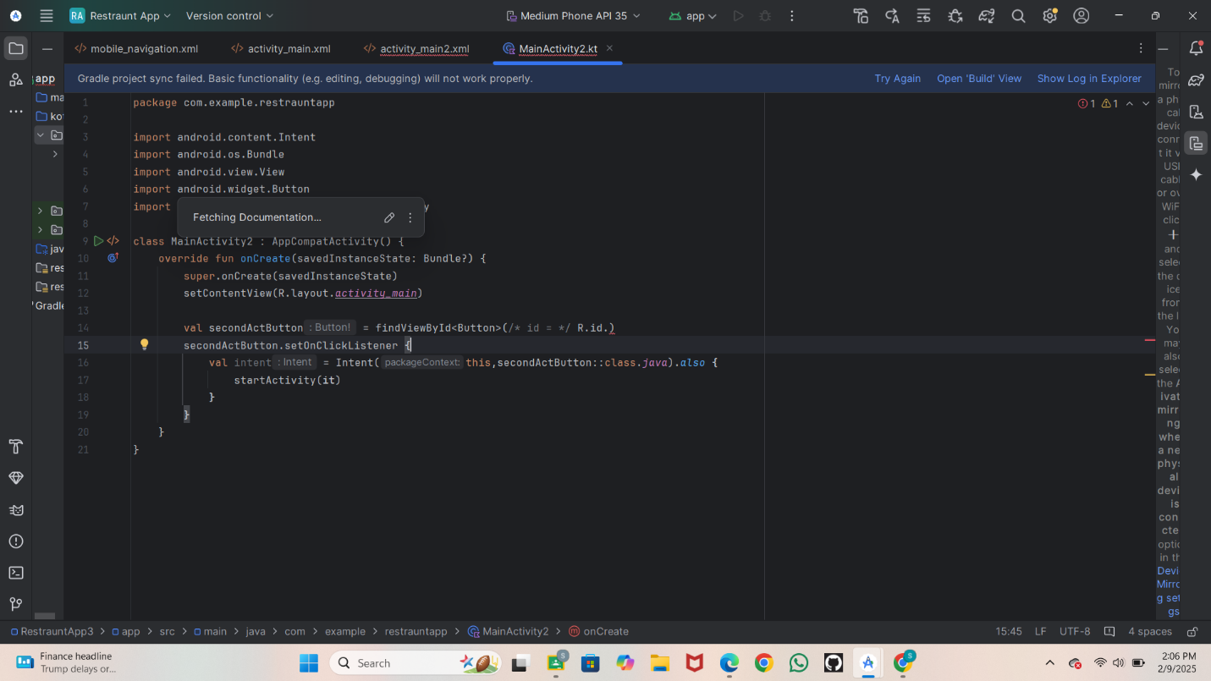

**Step 4: Running the Application on Emulator**

* Click on the **Run** button in Android Studio.
* Select the emulator and launch the app.

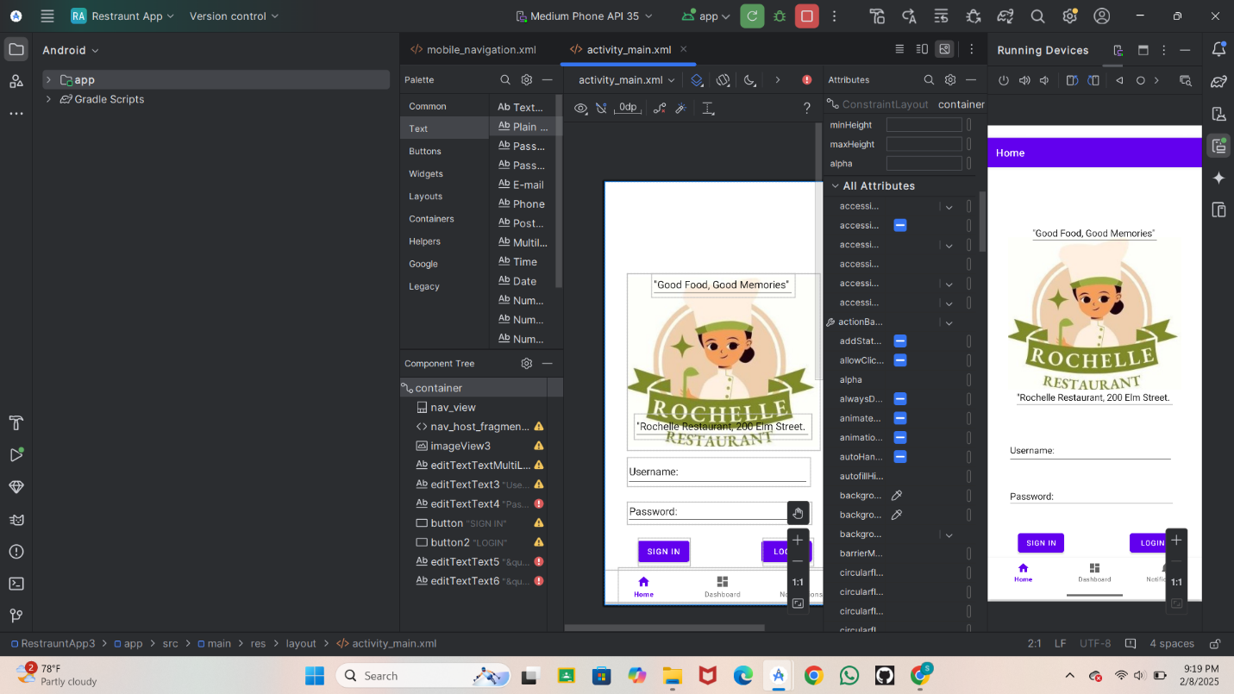

**Step 5: For NEW second page**

**Create a New Project**

* Create a new project.
* Choose an Empty Activity template.
* Set the project name and package name.
* Select the programming language (Java/Kotlin).

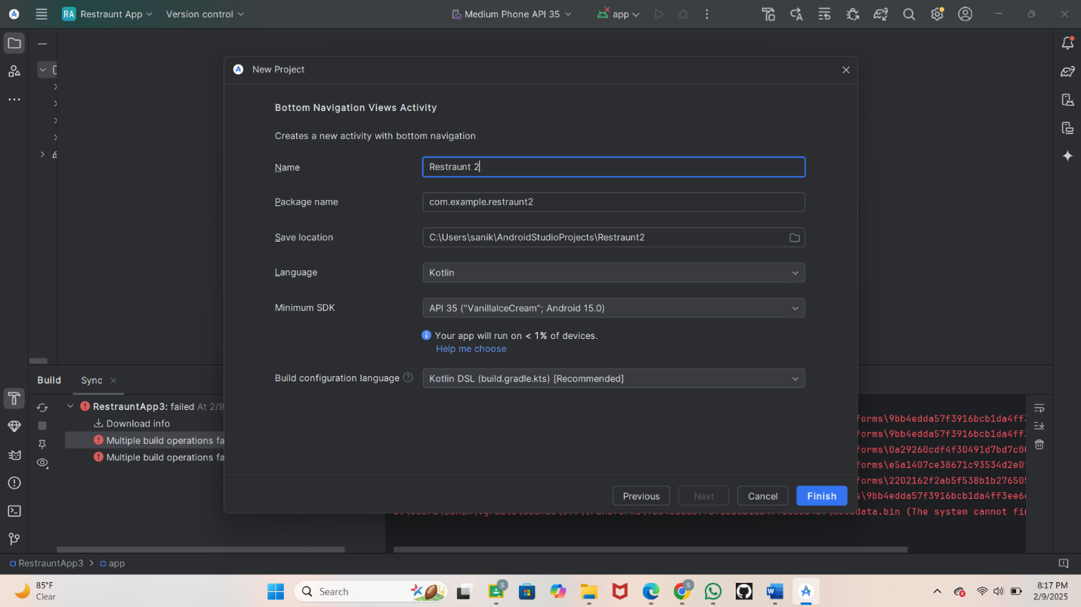 **Step -6: Designing the UI**

* Open activity_main.xml and design the layout using XML.
* Add UI comwponents such as TextView, EditText, Button, etc.

**Screenshot**

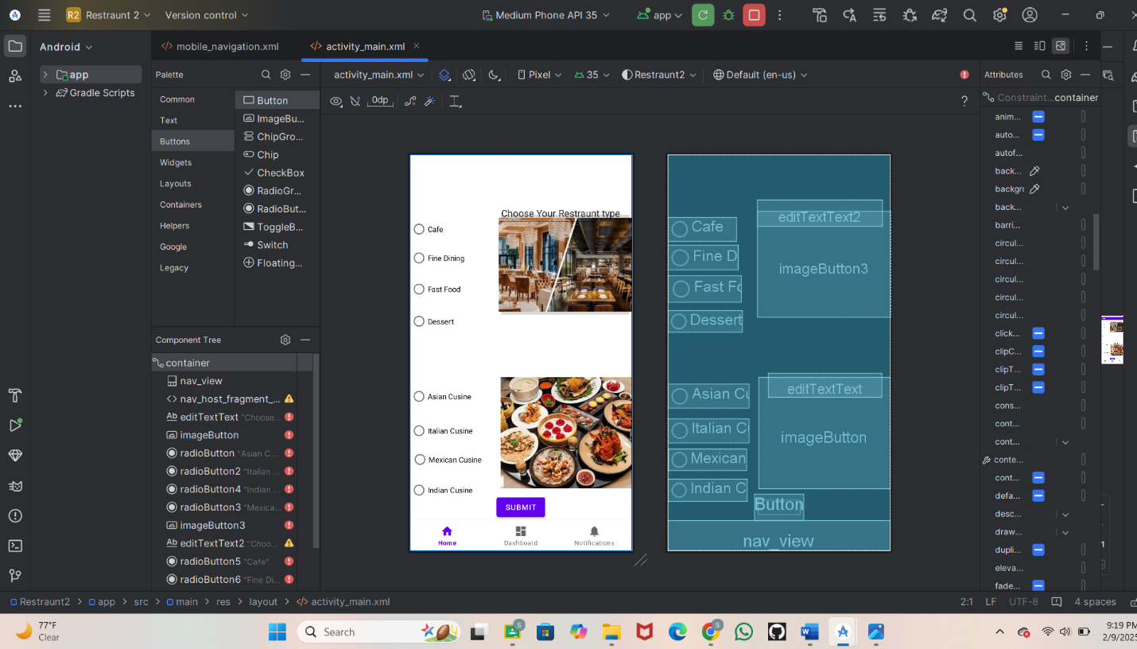**Step 7: Writing the Code**

* Open MainActivity.java or MainActivity.kt.
* Implement functionality such as button clicks, form validation, etc.
* Use necessary Android components like Intents, RecyclerView, Fragments, etc.

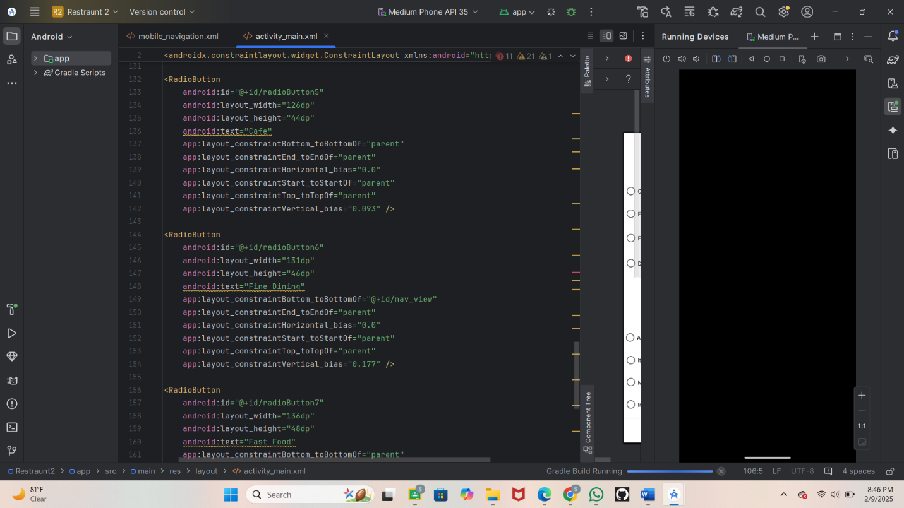 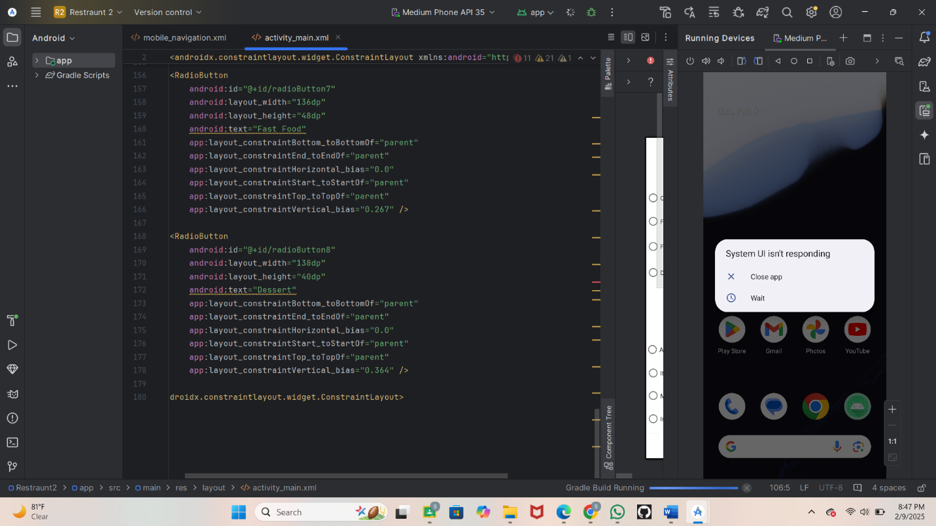 **Step 8: Running the Application on Emulator**

* Click on the **Run** button in Android Studio.
* Select the emulator and launch the app.

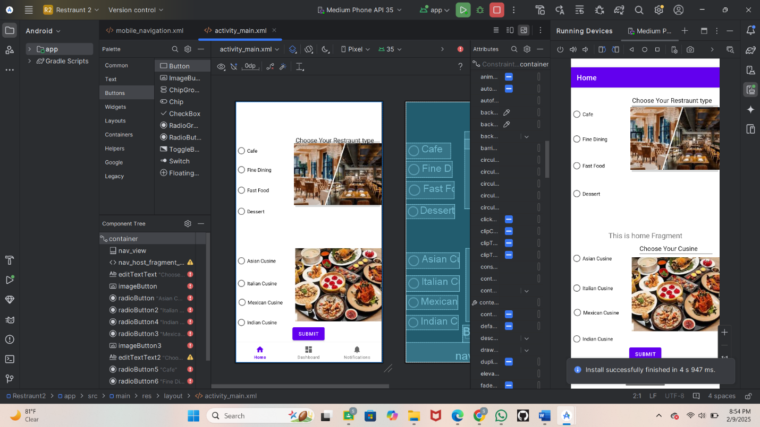**Conclusion:**

Creating a restaurant app with fields for name, location, and cuisine type, plus radio buttons for type, is a great idea. It will make it easy for users to add and manage restaurant info. The app will be helpful for restaurant owners and uses to keep track of restaurant details**.**